**HTML and CSS Tutorial**

1. Using Notepad++, create a new blank HTML file saving the file as ct_about.html.
2. Enter the following code into the file:

**<!DOCTYPE html>**

**<html>**

**<head> </head>**

**<body> </body>**

**</html>**

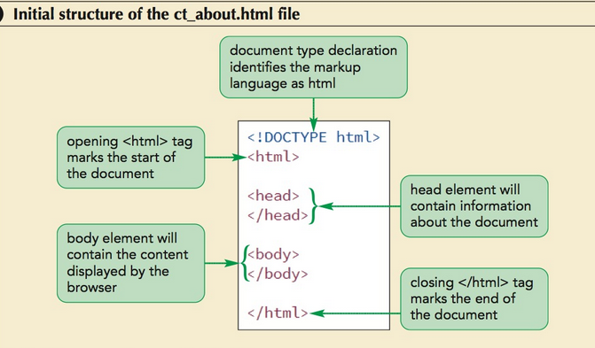

1. Save your changes to the file.
2. Directly after the opening <head> tag, insert the following title element, indented to make the code easier to read.

**<title>About Curbside Thai</title>**

1. Directly after the opening <head> tag, insert the following meta elements, indented to make the code easier to read:

**<meta charset=”utf-8” /> <meta name=”keywords”**

**content=”Thai, restaurant, Charlotte, food” />**

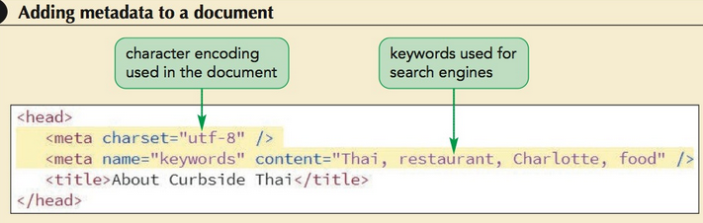

1. Save your changes to the file.
2. Open the ct_about.html file in your browser. Confirm that the browser tab or browser title bar contains the text “About Curbside Thai”. There should be no text displayed in the browser window because you have not added any content to the page body yet.

**To add a comment to the document:**

1. Return to the ct_about.html file in your HTML editor.
2. Directly after the opening <head> tag, insert the following comment text, indented to make the code easier to read:

**<!--**

**HTML5 and CSS3, Tutorial 1**

**General Information about Curbside Thai**

**Author: your name**

**Date: today’s date**

**Filename: ct_about.html**

**-->**

where your name is type your name and today’s date, and save your changes

1. To define the sections in the page body:
2. Go back to the ct_about.html file in your HTML editor.
3. Directly after the opening <body> tag, insert the following HTML code, indented to make the code easier to read:

**<header> <h1>Curbside Thai</h1>**

**</header> <article>**

**<h1>About Us</h1> </article>**

**<footer> Curbside Thai 411 Belde Drive, Charlotte NC 28201 704-555-1151**

**</footer>**

**To group the page text into paragraphs:**

1. Use a text editor to open the ct_pages.txt
2. Select and copy the three paragraphs of text directly after the About Us title.
3. Close the file, but do not save any changes you may have inadvertently made to the document.
4. Return to the ct_about.html file in your HTML editor.
5. Directly after the <h1>About Us</h1> line within the page article, insert a new blank line and paste the text you copied.
6. Enclose each of the three paragraphs of pasted content between an opening <p> tag and a closing </p> tag. Indent the code within the article element to make the code easier to read.
7. 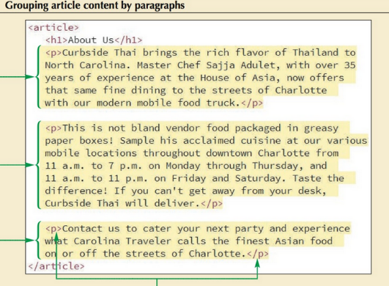Save your changes to the file.

**To apply text-level elements to a page:**

1. Go to the first paragraph within the page article and enclose the opening words Curbside Thai within a set of opening and closing <strong> tags. You use the <strong> tags when you want to strongly reinforce the importance of the text, such as the restaurant name, for the reader.
2. In the second paragraph, enclose the phrase, Curbside Thai will deliver within a set of opening and closing <em> tags to emphasize this text.
3. Go the third paragraph and mark Carolina Traveler using the cite element and then mark the extended quote, the finest Asian food on or off the streets of Charlotte, using the q element.

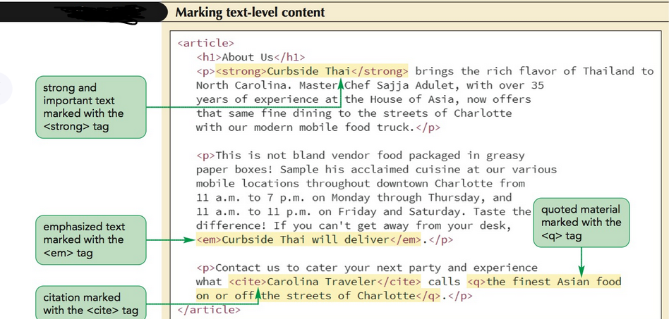

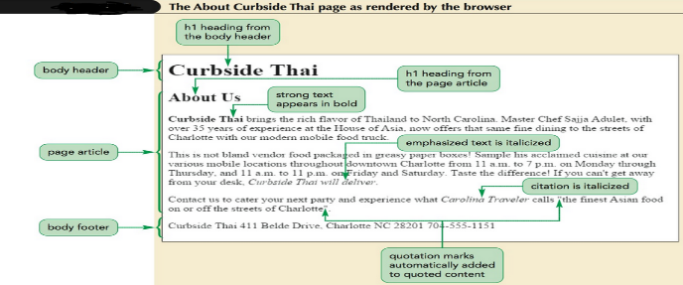23. Save your changes to the file and Open the ct_about.html file in your browser to view how your browser renders the page content.

**To link an HTML document to a style sheet:**

1. Return to the ct_about.html file in your HTML editor.
2. Directly before the closing </head> tag, insert the following link elements:

**<link href=”ct_base.css” rel=”stylesheet” />**

**<link href=”ct_layout2.css” rel=”stylesheet” />**

1. Save your changes to the file and then reload the ct_about.html file in your browser.

**To insert a character encoding reference number and an entity reference:**

1. Return to the ct_about.html file in your HTML editor.
2. Go to the footer element and insert the character encoding number **&#8226**; directly after the word Thai and after the postal code 28201. Insert the character reference **&nbsp**; directly before the postal code.
3. Save your changes to the file and then reload the ct_about.html file in your browser.

**To insert inline images into a document:**

1. Return to the ct_about.html file in your HTML editor.
2. Go to the header element and replace the h1 element with the tag

**<img src=”ct_logo2.png” alt=”Curbside Thai” />**

1. Go to the article element and, directly after the h1 element, insert the tag

**<img src=”ct_photo1.png” alt=”” />**

1. Save your changes to the file and then reload the ct_about.html file in your browser.

**To create the reviews page:**

1. Open the ct_reviews_txt.html file in your HTML editor.
2. Enter your name and the date in the comment section and save the file as ct_reviews.html.
3. Go to the ct_pages.txt file in your text editor. 3. Locate the section containing the restaurant reviews and copy the text of the four reviews and awards.
4. Return to the ct_reviews.html file in your HTML editor and paste the text of the four reviews directly after the <h1>Reviews</h1> line.
5. Enclose each review within a set of <blockquote> tags. Enclose each paragraph within each review with a set of <p> tags. Align and indent your code to make it easier to read.
6. Save your changes to the file and then open the ct_reviews.html file in your browser.

**To create the Catering page:**

1. Open the ct_catering_txt.html file from the folder in your HTML editor. Enter your name and the date in the comment section and save the file as ct_catering.html.
2. Return to the ct_pages.txt file in your text editor.
3. Locate the section containing information about Curbside Thai’s catering service and copy the four paragraphs of information.
4. Return to the ct_catering.html file in your HTML editor and paste the copied text directly after the <h1>Catering</h1> line.
5. Mark each paragraph in the article using the p element. Align and indent your code to make it easier to read.
6. Directly after the <h1>Catering</h1> tag, insert an inline image using ct_photo2.png as the source and an empty text string for the alt attribute.
7. Save your changes to the file and then open the ct_catering.html file in your browser.

**To create the Contact Us page:**

1. Open the ct_contact_txt.html file from the folder in your HTML editor. Enter your name and the date in the comment section and save the file as ct_contact.html. Note that this page is linked to two style sheets that Sajja created.
2. Go to the ct_pages.txt file in your text editor.
3. Copy the Contact Us section in the text file (excluding the title).
4. Return to the ct_contact.html file in your HTML editor and paste the copied text directly after the <h1>Contact Us</h1> tag.
5. Enclose the introductory paragraph within a set of opening and closing <p> tags to mark it as a paragraph.
6. Enclose the three lines containing the street address within a set of opening and closing <address> tags to mark that content as an address. Insert the <br /> tag at the end of the first two lines to create a line break between the name of the restaurant and the street address.
7. Mark the last two lines as paragraphs using the p element. Save changes to the file and open the ct_contact.html file in your browser.

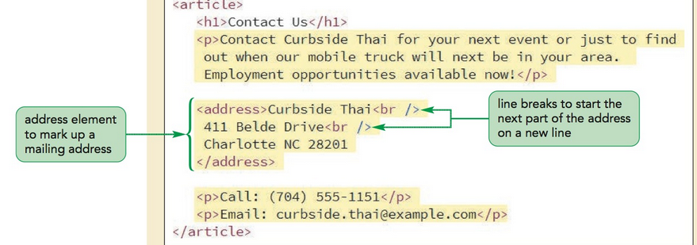

**To complete the Menu Page**

1. Open the ct_menu_txt.html file from the folder in your HTML editor. Enter your name and the date in the comment section and save the file as ct_menu.html.
2. Open the ct_pages.txt file in your text editor if it is not already open and copy the five menu items listed in the Mobile Menu section.
3. Return to the ct_menu.html file in your HTML editor and paste the copied text directly after the <h1>Mobile Menu</h1> tag.
4. Enclose the entire menu within an opening and closing <dl> tag.
5. Mark the name of each menu item using the dt element. Mark the corresponding description using the dd element. Indent your code to make it easier to read and interpret.
6. Save your changes to the file and then open the ct_menu.html file in your browser.

**To Create a Page of Times and Locations:**

1. Open the ct_locations_txt.html file from the folder in your HTML editor. Enter your name and the date in the comment section and save the file as ct_locations.html.
2. Return to the ct_pages.txt file in your text editor and copy the four locations from the Today’s Locations section.
3. Return to the ct_locations.html file in your HTML editor and paste the copied text directly after the <h1>Today's Locations</h1> tag.
4. Mark the entire list of times and locations using the dl element. Mark each time using the dt element and each location using the dd element. Indent your code to make it easier to read and interpret.
5. In order to distinguish this description list from other description lists in the website, add the attribute id=”ct_locations” to the opening <dl> tag.
6. Sajja has a map that he wants displayed alongside the list of times and locations. Directly after the h1 element within the article element, insert the following inline image:

**<img src=”ct_map.png” alt=”” />**

1. Save your changes to the file and then open the ct_locations.html file in your browser.

**To Create a Navigation List:**

1. Open the ct_about.html file in your HTML editor if it is not already open.

2. Go to the body header and, directly below the inline image for the Curbside Thai logo, insert the following navigation list:

**<nav> <ul>**

**<li>About</li> <li>Locations</li> <li>Menu</li> <li>Reviews</li> <li>Catering</li> <li>Contact</li>**

**</ul> </nav>**

Save your changes to the file and then reopen the ct_about.html file in your browser.

**To create hypertext links:**

1. Return to the ct_<.about.html file in your HTML editor.
2. Mark the first entry as a hypertext link pointing to ct_about.html file by changing the list item to

**<a href=”ct_about.html”>About</a>**

1. Change the code of the second list item to

**<a href=”ct_locations.html”>Locations</a>**

1. Continuing in the same fashion, change the Menu entry to a link pointing to the ct_menu.html file, the Reviews entry to a link pointing to the ct_reviews.html file, the Catering entry to a link pointing to the ct_catering.html file, and the Contact entry to a link pointing to the ct_contact.html file.
2. Save your changes to the file and then reopen the ct_about.html file in your browser.
3. Click each of the six navigation list entries and verify that the browser loads the corresponding web page. Use the Back button on your browser to return to the About Curbside Thai page after you view each document.

**To mark an image as a hypertext link:**

1. Return to the ct_about.html file in your HTML editor.
2. Mark the image in the body header as a hyperlink by changing the HTML code to

**<a href=”ct_start.html”><img src=”ct_logo2.png” alt=”Curbside Thai” /></a>**

1. Save your changes to the file and then reopen the ct_about.html file in your browser.
2. Click the Curbside Thai logo and verify that the browser opens the Curbside Thai Startup page. Click the Back button to return to the About Curbside Thai page.

**To copy and paste the hypertext links:**

1. Return to the ct_about.html file in your HTML editor.
2. Copy the entire content of the page header from the opening <header> tag through to the closing </header> tag, including the revised code for the company logo and navigation list.
3. Go to the ct_locations.html file in your HTML editor. Paste the copied HTML code, replacing the previous page header in this document. Save your changes to the file.

4. Repeat the previous step for the ct_menu.html, ct_reviews.html, ct_catering.html, and ct_contact.html files, replacing the body header in each of those documents with the revised header from ct_about.html. Save your changes to each file.

5. Reopen the ct_locations.html file in your browser and verify that you can jump from one page to another by clicking items in the navigation list at the top of each page. Also verify that you can jump to the Startup page at any time by clicking the Curbside Thai logo.

**To link to an e-mail address & telephone number:**

1. Go to the ct_contact.html file in your HTML editor.
2. Change the Curbside Thai e-mail address into the following mailto hypertext link:

**<a href=”mailto:curbside.thai@example.com”>**

**curbside.thai@example.com**

**</a>**

Note that this is a fictional e-mail address. If you want to test this link, change the URL to a link pointing to your own e-mail address.

Save your changes to the file and then reopen the ct_contact.html file in your browser.

Return to the ct_contact.html file in your HTML editor. 2. Change the Curbside Thai phone number into the following hypertext link:

**<a href=”tel:+17045551151”>**

**(704) 555-1151**

**</a>**